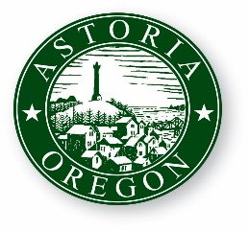
AGENDA

ASTORIA CITY COUNCIL WORK SESSION
WEDNESDAY, JULY 11, 2018
9:00 AM
2nd Floor Council Chambers
1095 Duane Street Astoria OR 97103

- CALL TO ORDER

- ROLL CALL

- Presentation on Library Remodel from Hennebery Eddy Architects

- ADJOURNMENT

